New Patient Pain Assessment Form
Name ________________________________________
DOB __________ Height _________ Weight _________
Current Occupation:_____________________________

1. Where is your pain located? _________________________
__________________________________________________
2. When did your pain begin?__________________________
3. Does the pain radiate or travel to other areas?
__________________________________________________
4. Is your pain: (please check answer)
□ Intermittent □ Continuous □ Both?
5. Does your pain vary in intensity? □ Yes □ No
6. Does anything bring on or trigger your pain? ___________
If so, what? ______________________________________
7. Was there an injury or accident that caused your pain?
__________________________________________________
8. Please check the word(s) that descried your pain:
□ Aching □ Throbbing □ Shooting
□ Stabbing □ Gnawing □ Sharp
□ Tender □ Burning □ Exhausting
□ Tiring □ Penetrating □ Unbearable
□ Numb □ Miserable □Squeezing
□ Dull □ Radiating □ Knife-like
□ Crampy □ Deep
9. Rate the intensity of your pain:
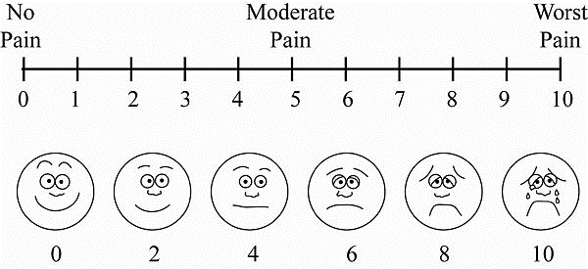
10. What makes the pain feel better? ___________________
__________________________________________________
__________________________________________________
11. List any treatments (if Applicable) that you have
received for your pain in the past: __________________
__________________________________________________

Medical History
Do you have or are you currently being treated for:

Shade areas of pain
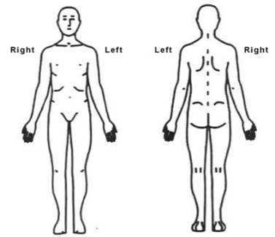

Front Back

12. What other doctors have you seen for this problem?
__________________________________________________
13. How does your pain affect your lifestyle? ($↑,↓$ , no change)
Sleep_____ Appetite_____ Activity_____ Energy_____
14. Are you experiencing any other symptoms?
(Check if applicable)
□ Nausea □ Sleepiness □ Weakness
□ Vomiting □ Confusion □ Itching
□ Constipation □ Difficulty urinating 
□ Loss of bowel/bladder control
15. Are you currently taking any blood thinners?
(i.e. Lovenox, Coumadin, Plavix, Aspirin)
□ Yes □ No List: ________________________________
16. Please list any allergies: ___________________________
__________________________________________________
17. Please list your current medications (including pain meds)
(If known please list dosages)
__________________________________________________
__________________________________________________
____________________________________________________________________________________________________
18. What non-steroidal anti-inflammatories have you used?
____________________________________________________________________________________________________
19. List Pharmacy Preference __________________________
20. Is there a chance you are pregnant? □ Yes □ No
Date of last Menses _______________________________
21. Do you have any Mental Health Conditions?___________
__________________________________________________
22. Family History of medical conditions: ________________
__________________________________________________
23. List Surgeries: ___________________________________
__________________________________________________
24. Implants: (i.e. pacemaker, defibrillator) ______________
__________________________________________________

Anemia | Yes | No | Glaucoma | Yes | No | Seizures | Yes | No
Arthritis | Yes | No | Headaches | Yes | No | Stroke | Yes | No
Asthma | Yes | No | Heart Disease | Yes | No | Street Drug Use | Yes | No
Back Problems | Yes | No | Hepatitis | Yes | No | Alcohol Use | Yes | No
Blood Disorder-Bruising | Yes | No | High Blood Pressure | Yes | No | Stomach Ulcers | Yes | No
Cancer | Yes | No | HIV | Yes | No | TB | Yes | No
Cataracts | Yes | No | Kidney Disease | Yes | No | Thyroid Disorders | Yes | No
Circulation Problems | Yes | No | Lung Disease | Yes | No | Smoke (packs a day_____) | Yes | No
Diabetes | Yes | No | Osteoporosis | Yes | No | Other:

Please complete other side
Do you have any of the following symptoms

☐ Balance problems ☐ Difficulty walking
☐ Inability to control bowel (incontinence) ☐ Inability to control bladder (incontinence)
☐ The need for an assistive device to walk (cane, wheelchair or walker)
☐ Weakness ☐ Numbness or tingling, where ______________
☐ Fever/Chills
☐ I have none of these symptoms

Review of systems

Constitution | Eyes | Gastrointestinal | Neurological
☐ Fever | ☐ Blurred vision | ☐ Heartburn | ☐ Dizziness
☐ Chills | ☐ Double vision | ☐ Nausea | ☐ Tingling
☐ Weight loss | ☐ Light sensitivity | ☐ Vomiting | ☐ Tremor
☐ Fatigue | ☐ Eye pain | ☐ Diarrhea | ☐ Sensory change
☐ Excessive sweating | ☐ Eye discharge | ☐ Abdominal pain | ☐ Speech change
☐ N/A | ☐ Eye redness | ☐ Constipation | ☐ Focal weakness
Skin | ☐ N/A | ☐ Blood in stool | ☐ Seizures
☐ Rash | Cardiovascular | ☐ Black stool | ☐ Loss of consciousness
☐ Itching | ☐ Chest pain | ☐ N/A | ☐ N/A
☐ N/A | ☐ Rapid heart rate | Genitourinary | Psychiatric
Head/ENT | ☐ Shortness of breath when laying down | ☐ Painful urination | ☐ Depression
☐ Headaches | ☐ leg discomfort when walking | ☐ Sudden need to urinate | ☐ Suicidal ideation
☐ Hearing loss | ☐ Leg swelling | ☐ Frequency | ☐ Substance abuse
☐ Ringing in ears | ☐ Breathing difficulty at night while laying down | ☐ Blood in urine | ☐ Hallucinations
☐ Ear pain | ☐ N/A | ☐ Pain in upper abdomen or back | ☐ Nervous/Anxious
☐ Ear discharge | Respiratory | ☐ N/A | ☐ Insomnia
☐ Nose bleeds | ☐ Cough | Endo/Allergy/Heme | ☐ Memory loss
☐ Congestion | ☐ Coughing up blood | ☐ Easy bruise/bleed | ☐ N/A
☐ High-pitched sound when breathing | ☐ Excessive phlegm/mucus | ☐ Environmental allergies
☐ Sore throat | ☐ Shortness of breath | ☐ Excessive thirst
☐ N/A | ☐ Wheezing | ☐ N/A
 | ☐ N/A

Patient signature __________________________________________ Date: ______________________

