Pain Assessment Form
Name ________________________________________
DOB __________ Height _________ Weight _________
Current Occupation:_____________________________

1. Where is your pain located? _________________________
__________________________________________________
2. When did your pain begin?__________________________
3. Does the pain radiate or travel to other areas?
__________________________________________________
4. Is your pain: (please check answer)
□ Intermittent □ Continuous □ Both?
5. Does your pain vary in intensity? □ Yes □ No
6. Does anything bring on or trigger your pain? ___________
If so, what? ______________________________________
7. Was there an injury or accident that caused your pain?
__________________________________________________
8. Please check the word(s) that descried your pain:
□ Aching □ Throbbing □ Shooting
□ Stabbing □ Gnawing □ Sharp
□ Tender □ Burning □ Exhausting
□ Tiring □ Penetrating □ Unbearable
□ Numb □ Miserable □Squeezing
□ Dull □ Radiating □ Knife-like
□ Crampy □ Deep
9. Rate the intensity of your pain:
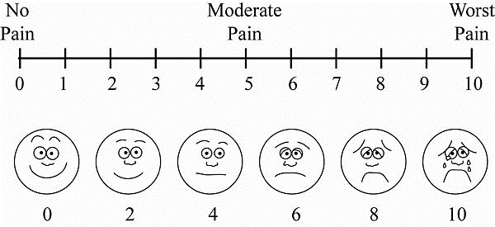
10. What makes the pain feel better? ___________________
__________________________________________________
__________________________________________________
11. List any treatments (if Applicable) that you have
received for your pain in the past: __________________
__________________________________________________

Medical History
Do you have or are you currently being treated for:

Shade areas of pain
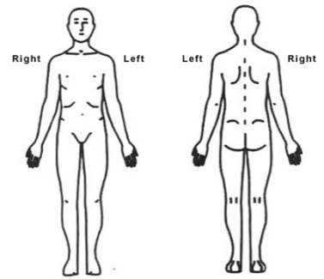

Front Back

12. What other doctors have you seen for this problem?
__________________________________________________
13. How does your pain affect your lifestyle? ($↑,↓$ , no change)
Sleep_____ Appetite_____ Activity_____ Energy_____
14. Are you experiencing any other symptoms?
(Check if applicable)
□ Nausea □ Sleepiness □ Weakness
□ Vomiting □ Confusion □ Itching
□ Constipation □ Difficulty urinating 
□ Loss of bowel/bladder control
15. Are you currently taking any blood thinners?
(i.e. Lovenox, Coumadin, Plavix, Aspirin)
□ Yes □ No List: ________________________________
16. Please list any allergies: ___________________________
__________________________________________________
17. Please list your current medications (including pain meds)
(If known please list dosages)
__________________________________________________
__________________________________________________
____________________________________________________________________________________________________
18. What non-steroidal anti-inflammatories have you used?
____________________________________________________________________________________________________
19. List Pharmacy Preference __________________________
20. Is there a chance you are pregnant? □ Yes □ No
Date of last Menses _______________________________
21. Do you have any Mental Health Conditions?___________
__________________________________________________
22. Family History of medical conditions: ________________
__________________________________________________
23. List Surgeries: ___________________________________
__________________________________________________
24. Implants: (i.e. pacemaker, defibrillator) ______________
__________________________________________________

Anemia | Yes | No | Glaucoma | Yes | No | Seizures | Yes | No
Arthritis | Yes | No | Headaches | Yes | No | Stroke | Yes | No
Asthma | Yes | No | Heart Disease | Yes | No | Street Drug Use | Yes | No
Back Problems | Yes | No | Hepatitis | Yes | No | Alcohol Use | Yes | No
Blood Disorder-Bruising | Yes | No | High Blood Pressure | Yes | No | Stomach Ulcers | Yes | No
Cancer | Yes | No | HIV | Yes | No | TB | Yes | No
Cataracts | Yes | No | Kidney Disease | Yes | No | Thyroid Disorders | Yes | No
Circulation Problems | Yes | No | Lung Disease | Yes | No | Smoke (packs a day_____) | Yes | No
Diabetes | Yes | No | Osteoporosis | Yes | No | Other:

Signature of person completing form _______________________________________________________ Date _____/_____/______

